**Software Development Life Cycle and Agile Principles3.0**

**Assignment 4: Create an infographic illustrating the Test-Driven Development (TDD) process. Highlight steps like writing tests before code, benefits such as bug reduction, and how it fosters software reliability.**

**Test Driven Development [TDD] Process:**

* Introduction to Test-Driven Development (TDD)
* Definition of TDD
* Significance and benefits of TDD

**The TDD Cycle:**

* Step 1: Write a failing test
* Step 2: Run the test (and see it fail)
* Step 3: Write the minimum code to pass the test
* Step 4: Run the test (and see it pass)
* Step 5: Refactor the code

Repeat the cycle for each new feature or functionality

**Benefits of TDD:**

* Early bug detection and prevention
* Improved code quality and reliability
* Better code documentation through tests
* Modular and flexible code design
* Increased confidence in code changes and refactoring

**How TDD Fosters Software Reliability:**

* Tests act as a safety net for the codebase
* Regression testing with each code change
* Encourages modular and testable code design
* Facilitates continuous integration and delivery
* Enables refactoring and code maintenance with confidence
* Challenges and Best Practices
* Initial learning curve and mindset shift
* Writing good tests (FIRST principles)
* Test code organization and maintenance

**Conclusion:** Summary of TDD's benefits and impact on software reliability.

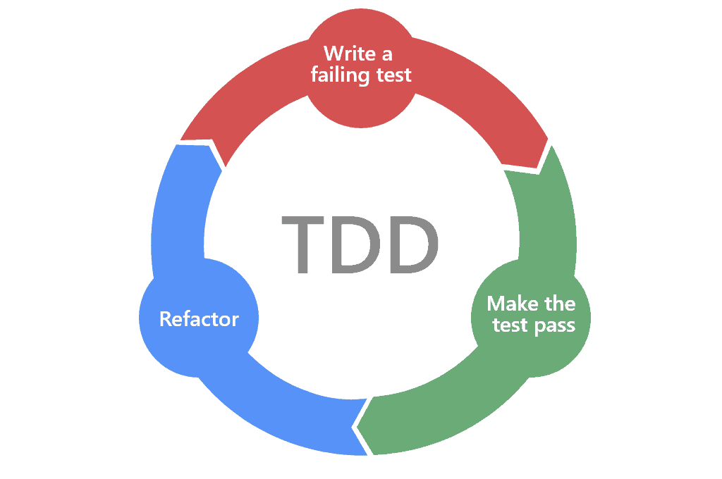

**1. Write Test:**

* Developers write automated tests for a small piece of functionality before writing the corresponding production code.
* Tests are written to define the desired behavior and functionality of the code.

**2. Run Test:**

* Automated test suite is executed to validate the code.
* Initial test will fail as no code has been written yet.

**3. Write Code:**

* Developers write the minimum amount of code necessary to make the failing test pass.
* Focus is on writing only what's needed to fulfill the test requirements.

**4. Run Test Again:**

* Automated test suite is executed again to verify that the newly written code passes the test.
* Test should now pass, indicating successful implementation of the functionality.

**5. Refactor Code:**

* Developers refactor the code to improve readability, maintainability, and performance.
* Refactoring is done without changing the behaviour of the code as verified by the tests.

**Benefits of TDD:**

* **Bug Reduction:** By writing tests first, developers catch bugs early in the development process, reducing the likelihood of defects in the final product.
* **Improved Code Quality:** TDD encourages developers to write clean, modular, and well- structured code that is easier to maintain and extend.
* **Increased Reliability:** With a comprehensive suite of automated tests, developers can confidently make changes to the codebase without fear of introducing regressions.

**How TDD Fosters Software Reliability:**

* **Continuous Testing:** TDD promotes a culture of continuous testing, where every code change is validated against a suite of automated tests.
* **Regression Prevention:** Automated tests act as a safety net, catching regressions and ensuring that existing functionality remains intact.
* **Early Feedback:** TDD provides immediate feedback on the correctness of code, allowing developers to quickly identify and fix issues.

**Assignment 5: Produce a comparative infographic of TDD, BDD, and FDD methodologies. Illustrate their unique approaches, benefits, and suitability for different software development contexts. Use visuals to enhance understanding.**

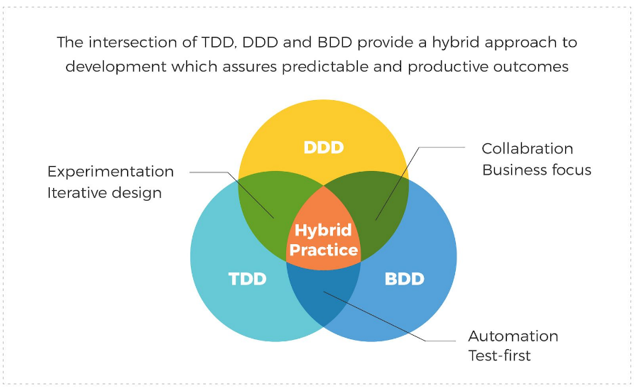

**1.Test-Driven Development (TDD):**

**Approach:**

* Developers write tests before writing production code.
* Focuses on writing small, incremental tests to drive the development process.

**Benefits:**

* Early Bug Detection: Catch bugs early in the development process.
* Improved Code Quality: Encourages clean, modular code design.
* Increased Confidence: Provides a safety net for refactoring and code changes.

**Suitability:**

* Ideal for projects with clear and well-defined requirements.
* Best suited for small to medium-sized projects with a focus on code reliability.

**2. Behaviour-Driven Development (BDD):**

**Approach:**

* Focuses on behaviour and outcomes rather than implementation details.
* Uses natural language specifications (e.g., Given-When-Then) to define tests.

**Benefits:**

* Enhanced Collaboration: Promotes collaboration between developers, testers, and stakeholders.
* Improved Communication: Helps ensure alignment between technical and non- technical team members.
* User-Centric: Tests are written from the perspective of end-users, ensuring that features meet their needs.

**Suitability:**

* Suitable for projects with complex business logic and evolving requirements.
* Best suited for teams that prioritize collaboration and communication.

**3. Feature-Driven Development (FDD):**

**Approach:**

* Focuses on building features incrementally based on client priorities.
* Emphasizes short iterations and frequent client feedback.

**Benefits:**

* Incremental Delivery: Delivers tangible results to clients in short cycles.
* Client-Centric: Aligns development efforts with client priorities and business objectives.
* Scalable: Scales well for large, complex projects with multiple teams.

**Suitability:**

* Suitable for large-scale projects with evolving requirements and multiple stakeholders.
* Best suited for projects where client involvement and feedback are essential.

**Conclusion:** Each methodology offers a unique approach to software development, catering to different project requirements and team dynamics. Whether it's the test-driven approach of TDD, the collaborative nature of BDD, or the feature-centric approach of FDD, choosing the right methodology depends on factors such as project size, complexity, and stakeholder involvement.